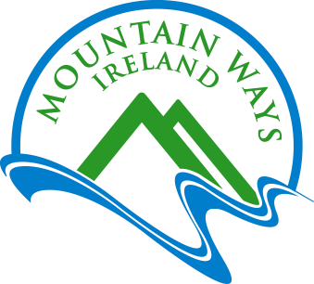With Compliments
Kit List
Please print and check off this list before you leave for your event:

Minimum Required Kit List…. MUST HAVE!
This is a normal 3 season Mountain walk kit list but obviously with colder weather, kit should be adapted to reflect the current conditions.

Mountain walking boots or footwear designed for off trail use suitable for mountain conditions.
- Walking trousers or tracksuit bottoms, jeans NOT recommended (Cotton is never a good idea)
- Waterproof coat with hood
- Spare layer e.g. fleece
- Hat and gloves
- Bottle of water
- Packed Lunch with extra – we burn plenty of calories in the hills !
- Any necessary personal medication e.g. inhaler
- Rucksack
- Big Smile 😊

Highly Recommended but non-essential Extras- Kit List
- Walking Poles
- Blister patches
- Camera
- Small flask of hot drink
- Clothing - Light layers combined are always better than one heavy layer.
- Waterproof Over-trousers.
- Extra chocolate bar or similar for snacking.
- Sun Cream
PLEASE NOTE:

- For both yours and group safety, anyone without appropriate footwear, or any of minimum kit list etc. may not be permitted to participate on the day, no refund will be given. This is at the discretion of the walk leader.
- No Dogs allowed.
(We are dog lovers but unfortunately not on our guided walks.)

Prevailing Weather Forecast
If you would like to keep an eye on the weather in advance, then we recommend:
https://www.mountain-forecast.com/peaks/Slieve-Donard/forecasts/850
This forecast link above is obviously for the summit of Slieve Donard in The Mourne Mountain Range however most mountain ranges and summits in Ireland can be found on this site.
Conditions can be viewed for both sea-level and summit elevations.
Remember! With the higher elevation then temperatures drop significantly, and windchill can be a significant additional factor.
But remember a forecast is just that and Irelands mountains are renowned for their changeable weather patterns.

If you have any questions in advance about kit or anything else, please contact us by e-mail:
Info@mountainwaysireland.com
or
Call our land line: +44 (0) 2830 570220
Call/Text/What’s app our mobile / cell: +353 (0) 87 224 3176

www.mountainwaysireland.com

info@mountainwaysireland.com

+ 353 (0) 87 224 3176

Escape
-

Embrace
–
Enjoy

